**Commodore Port Breakout: Cassette Output Rev. 0**

**Module Description**

# Introduction

This assembly provides the edge connector for a Commodore PET Cassette Port. It is also suitable for the C64, C128 and VIC-20 cassette port. The purpose is connecting it to the Cassette Breakout board via a ribbon cable.

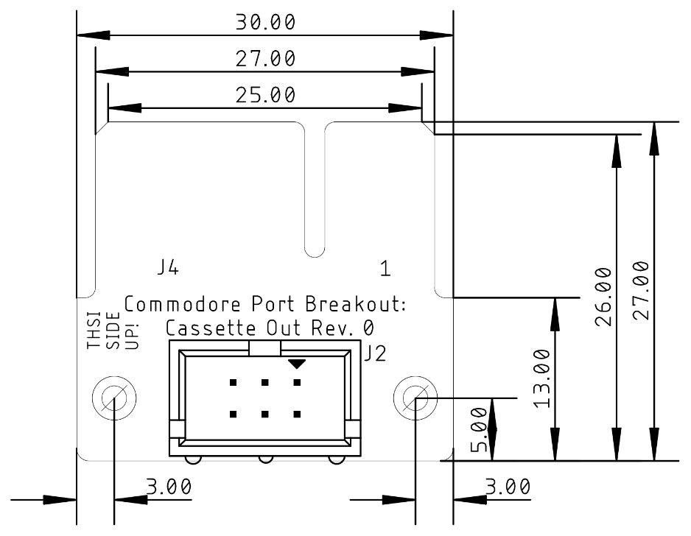

Figure 1: Dimensions of the PCB

# Connector Pinout

|  |  |  |
| --- | --- | --- |
| J2 | Cassette Port | J4 |
| 1 | GND | 1 |
| 2 | +5V | 2 |
| 3 | MOTOR | 3 |
| 4 | READ | 4 |
| 5 | WRITE | 5 |
| 6 | SENSE | 6 |
| (1) | GND | A |
| (2) | +5V | B |
| (3) | MOTOR | C |
| (4) | READ | D |
| (5) | WRITE | E |
| (6) | SENSE | F |

# Revision History

## Rev. 0

* Prototype